# Lab-10-2: AWS Networking Checkpoint

# 8 points

# Submission By: 24 Sept 5pm on Teams-> Assignment.

# Name:

# Objectives

* Setup virtual networking with subnets on AWS
* Deploy web application on aws subnet



--------------------------------------------------------------------------------------------------

# Create a Virtual Private Network (VPC) and host a webserver inside a public subnet

# In this task, you are going to setup a virtual network in AWS, that has both private and public subnets that spans multiple availability zones.

# The network is shown below:

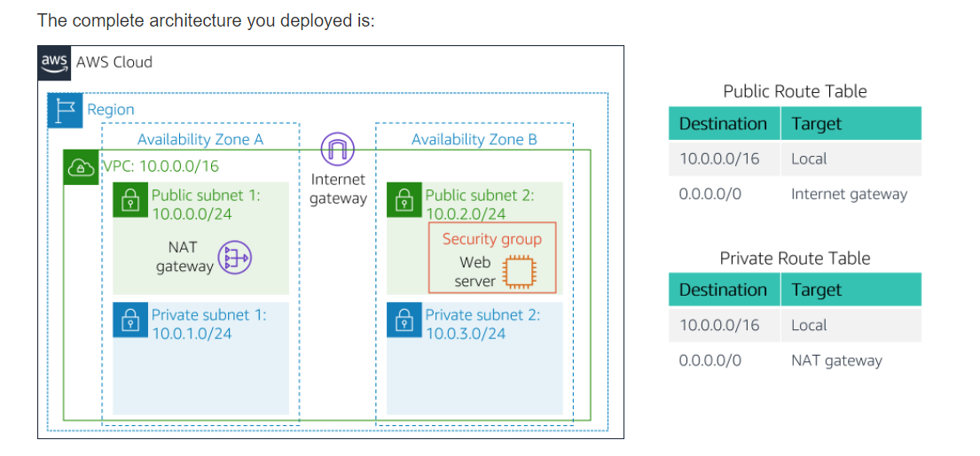

# You will do the following to meet the specification provided on the above diagram:

# ~~Create a VPC with subnets (1 points)~~

# Create routing table entries (1 points)

# Configure a security group (1)

# launch an ec2 instance on VPC and access through your browser (5 points)

# Create VPC and the Subnets:

# ----------------------------

# ~~1. Open the VPC service from AWS Management Console~~

# ~~2. Launch VPC~~

# ~~3. Create a public ip~~

# ~~4. Select 'vpc wih public and private subnets' from left panel~~

# ~~- vpc name: OPBIT~~

# ~~- public subnet name: Public Subnet 1~~

# ~~- select the first availability Zone~~

# ~~- private subnet name: Private Subnet 1~~

# ~~- select the first availability Zone~~

# ~~- pick the elastic ip~~

# ~~5. Create two more subnets~~

# ~~- select subnets from left panel~~

# ~~- select the VPC you created~~

# ~~- Select second availability Zone for this~~

# ~~two subnets: Public Subnet 2 and~~

# ~~Private Subnet 2~~

# ~~- put corresponding CIDR for these~~

# ~~two subnets (Refer to the diagram)~~

# ~~Create Routing Tables for private and public clouds~~

~~---------------------------------------------------------------------------~~

~~6. Create Routing Tables~~

~~- from left panel select Route Table~~

~~- Select the route table that has~~

~~Main=Yes and VPC=OPBIT~~

~~- Name this route table as Private Routing Table~~

~~- Change the subnet association to~~

~~Private subnet 1 and Public Subnet 1~~

~~7. Repeat step 6 for creating Routing Table for Public Subnets~~

~~- Select Main=No and VPC=OPBIT~~

~~Create Security Group~~

~~======================~~

~~Create the security group that allows inbound traffic to http~~

~~Launch a Web server instance~~

~~================================~~

~~Select the Amazon Linux 2~~

~~Select t2.micro~~

~~Configure instance details:~~

~~- set the instance at the public subnet 2 you created~~

~~- Copy and paste the following code as User data from~~

~~Advanced Details~~

|  |
| --- |
| #!/bin/bash  # Install Apache Web Server and PHP  yum install -y httpd mysql php  # Download Lab files  wget https://aws-tc-largeobjects.s3.amazonaws.com/AWS-TC-AcademyACF/acf-lab3-vpc/lab-app.zip  unzip lab-app.zip -d /var/www/html/  # Turn on web server  chkconfig httpd on  service https start |

~~Add Storage~~

~~Add Tag~~

~~Attach the security group you created early.~~

---------------------------------------------

**Submission:**

Paste the screen shot of the webserver accessed through from your web browser.